English | MONDAY  WE ARE GOING TO CONTINUE THINKING ABOUT OUR STORY ‘SUPERTATO’ THIS WEEK. TRY READING ALONG WITH THE STORY FOLLOWING THIS LINK.  https://www.youtube.com/watch?v=QlaMeNmTG6c  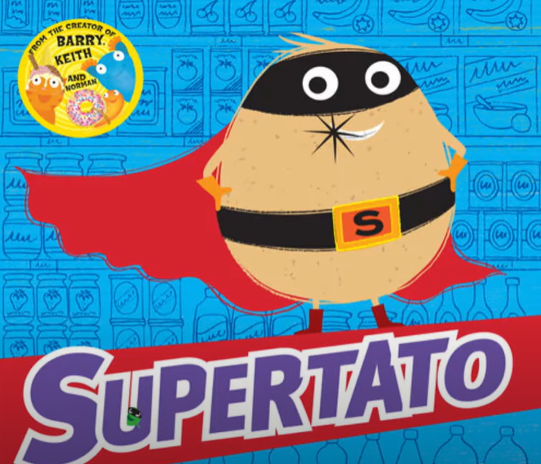  This week, we would like you to create your own Supertato story. Over the next few days you will have the chance to create your own Supervegetable characters, decide where the story will take place and plan and write your own special story.  Starter: Write the date correctly into your book – Check Capital Letters. ABC  Monday 8st June 2020  IALT: describe a character. Today, we would like you to choose fruit or vegetables to turn into your very own superheroes and villains?  .What words would you use to describe your character?  Did you use any of these words:  Brave strong kind friendly clever fast  Task: To create your own Super-vegetable characters.  - Draw a picture of your Super vegetable character.  - Write the name of your character.  - Label your picture – Use amazing adjectives if you can!!  Extension: Write sentences to describe your character. What does it look like and what super powers does it have?
TUESDAY

Starter: Write the date in your book.
Tuesday 9th June 2020
(Remember to use capital letters for days of the week and months of the year)

IALT: plan a story
Today, we are going to plan your own Super-vegetable story.

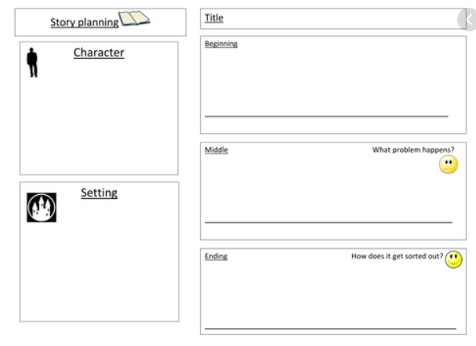

Where does your story take place?

How does it start?
What is the problem? How does it end?

Extension: Add exciting vocabulary to each box.

WEDNESDAY
English | Today, we are going to use speech in our story  Starter: Write the date correctly.  Wednesday 10rd June 2020.  IALT: use speech bubbles  Last week, we looked at using speech bubbles. When we use speech bubbles, we only put the words that are being spoken into the bubble.  HELP !!  Example:  MY NAME IS MRS CAREY  Today, we want you to think of some words that your character may say in the story and put these words into speech bubbles.  BROCCOLI BOY TO THE RESCUE!!!!  Your task  - Draw a character from your story.  - Draw a speech bubble beside the picture.  - Write words that your character would say inside the speech bubble.  - Repeat this with another character from your story.  Extension: Use different types of punctuation in your speech bubbles – full stops, question marks and exclamation marks.

THURSDAY
Today, you are going to write your very own Super-vegetable story!!

Starter: Write the date correctly:
Thursday 11th June 2020.
IALT: write a story
Look back at the plan that you wrote on Tuesday. Read it through and make sure that you can remember the story that you have created.

Your task:
- Read your plan.
- Write a super sentence to start your story. What phrases could you use to start: example: One quiet day……Once upon a time…..

- Write about your character. Use amazing adjectives!
Broccoli boy was as strong as a lion.

- Write about the problem that happens.
The naughty carrot had squashed the tiny tomatoes.

- How does your super-vegetable come to the rescue?
Broccoli boy tricked the naughty carrot.
- Write an ending for your story.
All the fruit and vegetables lived happily ever after.
- Read and check your work.
HELP!

English | FRIDAY  Each week we will continue to practise learning some words that we may like to use in our writing.  Please choose from Mild, Spicy or Hot words and write them in your book 5 times.  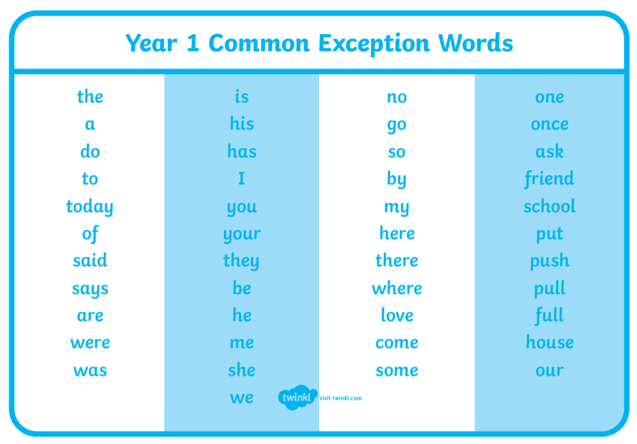  Task:  Mild: Spicy Hot  your there school  were friend full  push house pull  they come push  Extension: Put each word into a sentence and write this into your book.

