Draw like a Pro!  Complete a drawing activity with the Art Director of the Cbeebies show Pablo!  Either download the worksheets and complete or create your own version.  You will need: a pencil, pen or crayons.  https://www.bbc.co.uk/bitesize/articles/z6g2xyc | Marbled Paper Art  https://www.tate.org.uk/kids/make/paint-draw/make-marbled-paper-foam  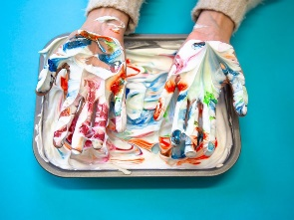  Make marbled paper and swirly patterns with foam. Be inspired by Gerhard Richter’s masterpieces. | Paint your own portrait in the garden!  Use a disposable sheet of white tablecloth or old bed sheet and ask an adult to pin it securely to the fence in your garden or hang it on the washing line. Then, choose your favourite colours and paint a self-portrait of yourself.
Make a Robot  Grab some bits and bobs from around the house and create an art-inspired robot.  https://www.tate.org.uk/kids/make/sculpture/make-robot  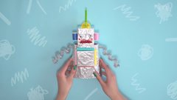 | 🌈Art  Home learning choices | 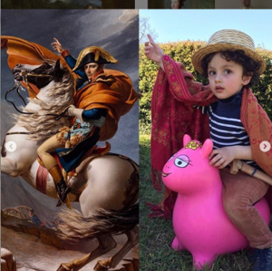  Copy the Painting!  Find a painting you like and try to recreate it like the picture. Get creative and imaginative and find things in your home that will help you dress up just like the portrait!
Forest Collage  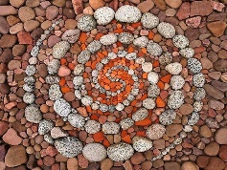  Research Andy Goldsworthy’s art. On your next walk outdoors, collect natural materials i.e. twigs, leaves etc and create your own natural masterpieces. | Sketch like an Impressionist  Watch this video clip about the artist Vincent Van Gogh.  https://www.bbc.co.uk/bitesize/clips/zdyr87h  Collect some items from around your home or in your garden and draw a still life picture, just like an Impressionist! Draw your items from different angles. | Sponge shield painting  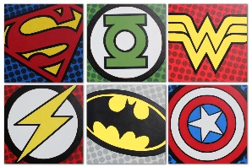  Linking to the Year 1 topic ‘Superheroes’ you could create a sponge painting of the superheroes emblem or shield. Can you use different shades of colour?

