Go Beanies

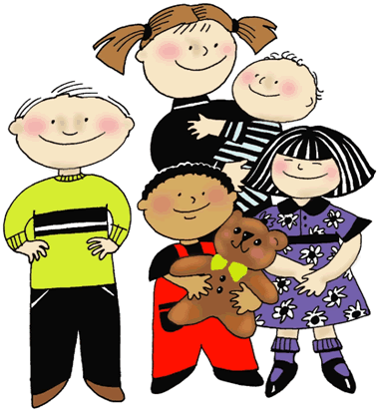

All About Me

My name is:
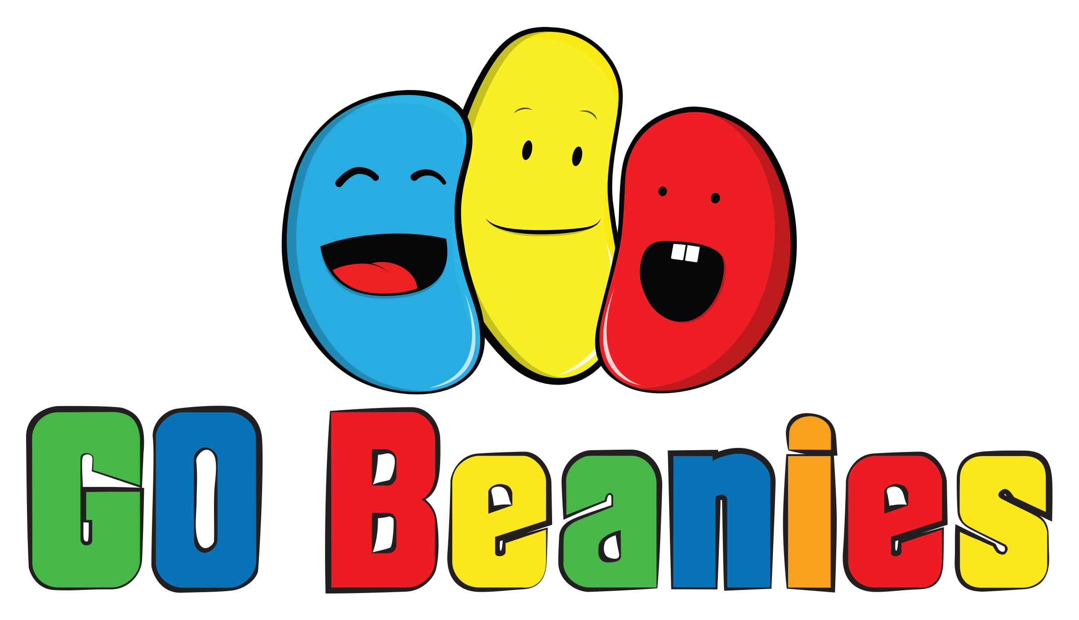

Introduction

Welcome to your child’s All About Me booklet. Please complete the booklet with your child and return it to us when the child starts at Go Beanies.

The information that you supply will help us to better understand your child’s likes and dislikes and will to ensure that your child settles in to the Club as quickly and easily as possible.

1. Parents’ Information

Child’s full name:

Name child is known by:

Date of birth:

Nationality:

Allergies:

Do you have any concerns about your child starting at the Club, or are there any areas that he/she requires help with?

Is there anything that you are aware of that might make it difficult for your child to settle at the Club (eg recent changes at home)?

Are you happy for us to share information about your child’s progress with his/her reception teacher? Yes / No
Child’s Page: Facts about me!

I live with:

At home the language we speak is:

The special days that we celebrate are:
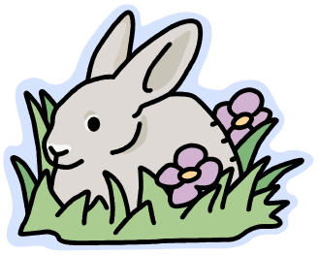

My pets are called:

At home, the toys I like to play with most are:

The things I really don’t like doing are:

My favourite foods are:

I don’t like to eat:

I like to drink:

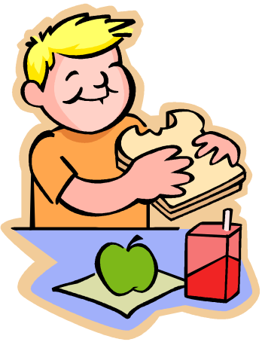
I don’t like to drink:

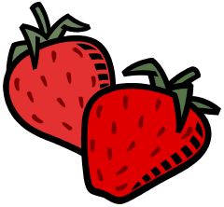

Child’s Page: Things to do at the Club

We have lots of games and activities for you to enjoy at the Club. Tick the boxes below to show us what types of things you would like to do when you come to the Club.

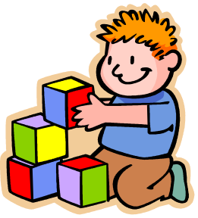
I like to play with:
◻ Construction toys (Lego, K’Nex etc)
◻ Cars
◻ Dolls
◻ Trains
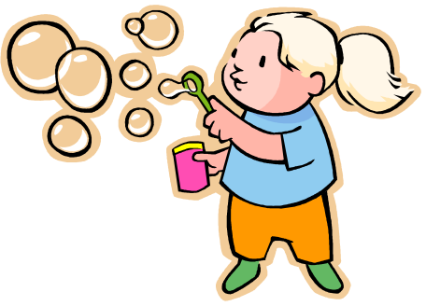
◻ Puzzles
◻ Board games
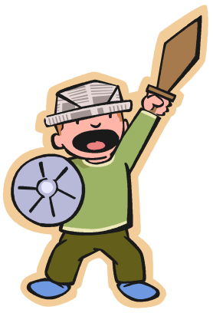
◻ Computer games / Wii

I like:
◻ Painting and drawing
◻ Dressing up

◻ Making dens
◻ Cooking
◻ Playing football
◻ Reading
◻ Crafts and making things

◻ Dancing

I prefer:
◻ Running around outside
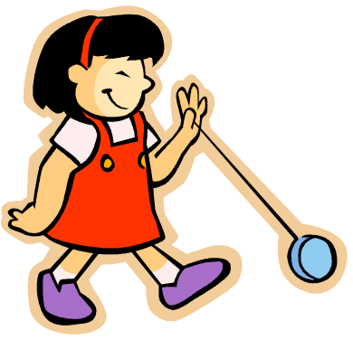
◻ A nice bit of quiet time
◻ Playing with lots of other children
◻ Playing by myself
◻ Playing with a few friends

