Civitas Academy Bulletin
24/02/20

Welcome from Mr Wieder
I hope that everyone had a restful half term break. This term we have World Book Day and our share a million stories taking place. A letter from Miss Frain will be accompanying the bulletin today informing you all of this exciting new challenge taking place this term.
A reminder that if there are any issues with your Tucasi account to speak to the office as bookings for parents evening will go live soon.
Club Cancellation
Please note that homework club has now finished. All other clubs are scheduled to continue until Friday 27th March.
ArtsMark Update from Miss Frain and Miss Edwards
Last term, Year 3 children took part in a lino-cutting and printing workshop with arts charity Jelly. The work they created, alongside other local schools, has contributed to a large collage in the Oracle- situated on the bridge on the first floor near BB's Cafe. This is part of our ongoing work towards our Silver Arts Mark award.
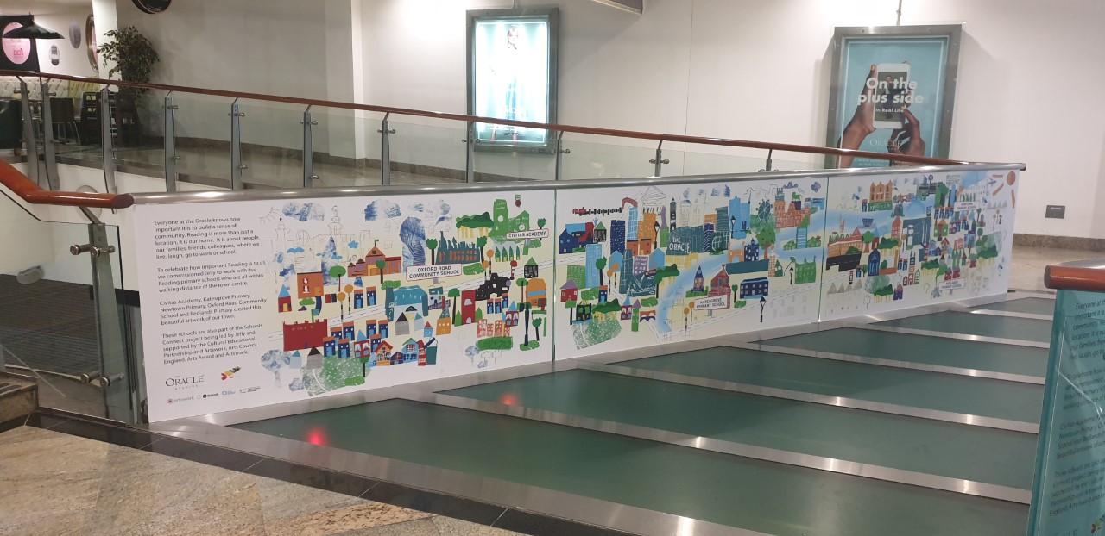

2019-20 Key Dates

Spring

Date and Time | Event
Thursday 5th March | World Book Day (parents welcome to spend upto 9:25am in classes to join in with reading activities. Children can come in dressed as a book character)
Tuesday 10th March (3:30-6pm) | Parents’ Evening
Thursday 12th March (3:30-6pm) | Parents’ Evening
Friday 13th March | Sports Relief
Friday 27th March | Spring clubs finish
Monday 30th March (3:30pm-4pm) | Project Celebrations
Thursday 2nd April | Y3 Easter Assembly
Friday 3rd April | End of Term
Summer
Date and Time | Event
Monday 20th April | Children return to school
Monday 27th April (3:30-4pm) | Term Overview Meeting
Thursday 7th May (9am-9:30am) | Question and Answer Session with Head of School
Thursday 14th May | EYFS Train Trip
Monday 18th May (3:30-4pm) | Project Celebration
Monday 18th- Friday 22nd May | Mental Health Week
Monday 25th-Friday 29th May | Half Term
Thursday 4th June (9:10- 9:40am) | Y2 Eid Assembly
Monday 8th-Friday 12th June | Cultural Diversity Week
Friday 12th June | International Day
Friday 12th June (3:30-4pm) | International Food Festival
Tuesday 30th June (AM) | Sports Day
Wednesday 1st July | Transition Day
Friday 3rd July | Sports Day (Reserve date in case of bad weather on Tuesday 30th June)
Thursday 9th July | Question and Answer Session with Head of School
Friday 10th July | Reports Out
Friday 17th July | Last day of term for children

