Civitas Academy Bulletin
11/12/17

Dear Parents and Carers,

Along the halls of Civitas the Christmas Spirit has most definitely arrived, children humming Christmas songs, decorations have gone up and the Christmas tree is looking glorious.

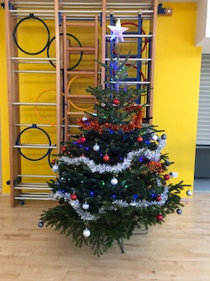

We look forward to welcoming our families to our different performances this week:

Tuesday 12th December – 2.00pm – Christmas Show, Buggies and Babies, the side gate will be open from 1.45pm and closed just before the show begins.

Wednesday 13th December – 2.00pm – Christmas Show, the side gate will be open from 1.45pm and closed just before the show begins.

Thursday 14th December – 9.30am – Christmas Show, the side gate will be open from 9.15am and closed just before the show begins.

WEBSITE: Our new school website has gone live!! There are a few little bits we are still adding on but please take your time to have a look. Thank you. www.civitasacademy.co.uk

Stars of the Week

Elmer – Lacey – for always listening and following instructions
Paddington – Saviir – for being a fantastic friend and demonstrating fantastic writing
Gruffalo – Megan – for improved attitude to learning
Pinocchio – Klenisa – for incredible improvement in writing
Matilda – Ariyah – for good learning behaviours and moving her learning on independently
BFG – Weronika – for being resourceful when improving her writing

Assembly:

In assembly today we shared with our children the BIG ATTENDANCE CHALLENGE we are launching on Friday 5th January 2018. With support from Reading Borough Council and REAch2 Academy Trust every child will earn a penny a day for every day they are in school and an extra penny each week for being on time. The class which has raised the most money will earn their own special reward too .All money raised will go to support a couple of local charities selected by the children. Every child that has 100% attendance next half term will also be able to attend our very special magic show at school!

Attendance:

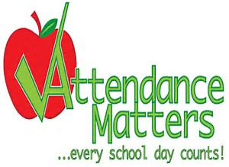

Our School Target for this year is 96.5%

Congratulations to Matilda class this week with a great 99.09% attendance.

Across the school we are all working hard to make improvements with our attendance. Our Whole school attendance this week was 93.75%, we need to

BFG – 94.55%
Matilda – 99.09%
Gruffalo – 96.98%
Pinocchio – 93.85%
Elmer – 87.24%
Paddington – 92.50%

Don’t forget Friday 15th December is Christmas Jumper day – Children are to wear their Christmas/Winter jumper with their school uniform. Suggested donations of £1, all money raised will go to ‘Save the Children’

https://christmasjumperday.org/

Key Dates:

Tuesday 12th December – Christmas show dress rehearsal 2.00pm – Parents with babies and buggies

Wednesday 13th December – Christmas show at 2.00pm

Thursday 14th December – Christmas show at 9.30am

Friday 15th December – Christmas Jumper Day – ‘Save the Children’ – Wear your Christmas jumper and make a donation to ‘Save the Children’

Friday 15th December – Pupils Christmas Lunch

Monday 18th December – Last day of After school club

Tuesday 19th December – Last day of term

Wednesday 3rd January 2018 – INSET DAY (School CLOSED to pupils)

Thursday 4th January 2018 – Pupils return to school (Breakfast and After school club begins)

Have a fantastic week.

Salima Ducker and Robert Wyld
Executive Head Teachers

School contact details:
Address – 90a Great Knollys Street
Reading
RG1 7HK
Tel: 0118 467 6720
Email: office@civitasacademy.co.uk
Web: www.civitasacademy.co.uk (currently under construction)
Twitter: @R2Civitas
Facebook: Civitas Academy
After School Club Tel: 07519938866

