Civitas Academy Bulletin
20/11/17

Dear Parents and Carers,

The children have been involved in some great conversations with their peers and teachers about why we should value our differences and how we can all help each other by bringing out the best in each other. Anti- bullying week provoked some great discussion around the theme:

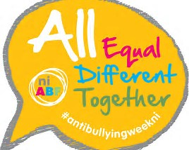

Please continue these valuable conversations at home, thank you.

Parking outside school:

Drop off and collection from school can always be a little tricky particularly if you are coming by car and when there is limited parking. Please only park in the permitted places. Residents on Great Knollys Street have permits and therefore they are the only cars that should be parked in the resident permit zones. We have had numerous complaints from residents about the parking from some of our families, particularly at pick up. We are part of the community, we want to work with our families and the local community to find solutions together. If you have any thoughts on how we can improve this, please drop me a line or pop into the office to make an appointment to see me.

Breakfast and After School Club

Please remember to book online in advance for both breakfast and/or after school club.
This can be done via Tucasi.

School Lunches:

These too can be ordered on Tucasi. Thank you for your support with this.

Star of the Week

Elmer – Anthony – for good listening and following instructions
Paddington – Faiz – for being a kind friend
Gruffalo – Adam – for super maths
Pinocchio – Tamzin – for always showing positive attitudes towards learning
Matilda – Sophia– for using resources to support her learning and working at the highest standard
BFG – Kaire – for putting in 100% and producing good work all week

Assembly:

Mr. Wyld’s assembly was about the responsibility to ‘influence’ our family and friends in a positive way and to be good when no one’s looking!

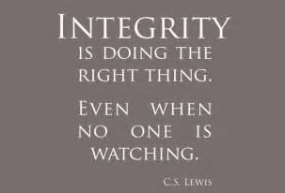

Attendance:

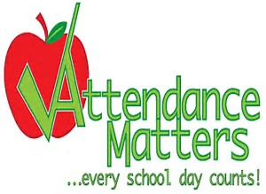

Our School Target for this year is 96.5%

Congratulations to Pinocchio class who had the highest attendance last week with 96.25%
Let’s get working with our attendance across the school. Check the weekly updates!

BFG – 87.73%
Matilda – 85.24%
Gruffalo – 94.38%
Pinocchio – 96.25%
Elmer – 89.23%
Paddington – 85.93%

Key Dates:

Thursday 7th December – Nasal vaccinations

Friday 8th December – INSET DAY (School CLOSED to pupils)

Tuesday 12th December – Christmas show dress rehearsal 2.00pm – Parents with babies and buggies

Wednesday 13th December – Christmas show at 2.00pm

Thursday 14th December – Christmas show at 9.30am

Friday 15th December – Christmas Jumper Day – ‘Save the Children’ – Wear your Christmas jumper and make a donation to ‘Save the Children’

Friday 15th December – Pupils Christmas Lunch

Monday 18th December – Last day of After school club

Tuesday 19th December – Last day of term

Wednesday 3rd January 2018 – INSET DAY (School CLOSED to pupils)

Thursday 4th January 2018 – Pupils return to school (Breakfast and After school club begins)

Have a fantastic week.

Salima Ducker and Robert Wyld
Executive Head Teachers
School contact details:
Address – 90a Great Knollys Street
Reading
RG1 7HK
Tel: 0118 467 6720
Email: office@civitasacademy.co.uk
Web: www.civitasacademy.co.uk (currently under construction)
Twitter: @R2Civitas
Facebook: Civitas Academy
After School Club Tel: 07519938866

