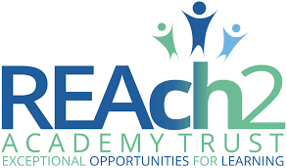

Our Curriculum Vision for ‘Our Civitas Child’ September 2022
“The curriculum is a framework for setting out the aims of a programme of education, including the knowledge and understanding to be gained at each stage (intent); for translating that framework over time into a structure and narrative, within an institutional context (implementation) and for evaluating what knowledge and understanding pupils have gained against expectations (impact/achievement)” OFSTED – working definition of curriculum

Intent
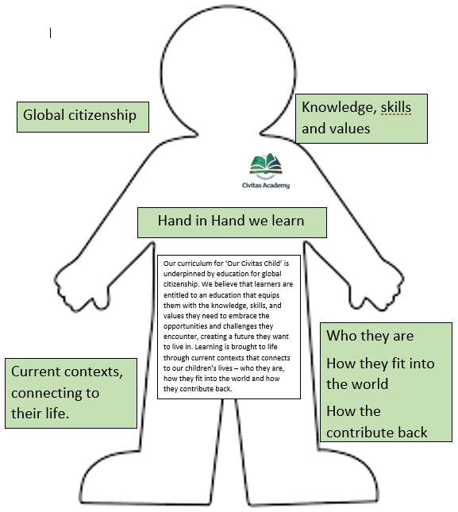
Our aim is to provide an excellent education for all our children, helping them develop the confidence, skills, curiosity and understanding to grow and progress academically, socially, and emotionally. Our curriculum is one which values teamwork and is solidified with our motto ‘hand in hand we learn’. Our curriculum promotes critical thinking as a global citizen and develops character skills for young people to make meaningful contributions to society.
Our three golden threads feature throughout our curriculum. These include:
VOR (Vocabulary, Oracy and Reading) | Powerful Knowledge | Community, Charity, and Citizenship
Vocabulary – We understand that developing children’s vocabulary is a vital part of their learning. It allows them to improve their reading, writing, listening, and speaking skills. We have multilingual children which is celebrated here. Teaching across all subjects, places key emphasis on the vocabulary learners require to successfully communicate their thinking. The use of communication in print in class scaffolds the children with EAL, SEND and lower attainers to access the learning and build upon their vocabulary.  Oracy skills – The importance of proficiency and skill in verbal communication cannot be overstated in the modern world, and our children will benefit from daily structured opportunities to develop these skills and regular formal opportunities to demonstrate these skills at school. Learning is inherently a social experience. Therefore, our teaching experiences promote richly dialogic contexts that support co-construction and collaboration. Discussion and debate and communication are all valuable currency in an increasing complex world and so we plan opportunities for children to express a point of view, understanding that people have different points of view and engaging with these. Children are able to consider different perspectives and points of views on global issues and we explore the potential of being able to change one’s point of view.  Reading skills – Our curriculum provides learners with daily opportunities to develop and apply their reading skills in a variety of contexts. It supports the way in which learners access new knowledge and secure knowledge in their long-term memory. The curriculum is strengthened at every opportunity by reading high quality texts which enhance children’s knowledge and experience of the world. | Powerful Knowledge: Our curriculum ensures that every child has access to the best that has been said, thought and done through human history in every subject area, which is illustrated on the long-term plans for each curriculum area. We want to ensure that children develop their knowledge of subjects, topics and concepts that are rich, powerful and cause children to develop their critical thinking skills.  We ensure our curriculum represents the children we teach by selecting high quality core texts that have diverse characters and/or authors from people of colour. Any significant people or events are carefully selected in all subjects to represent our children so they can be aspirational with their future as well as understand the challenges faced in the past. | Community: Civitas is the Latin word for community, and we feel it is important for the children to have a sense of belonging and enable them to develop their identity at Civitas. We are fortunate to be a part of a culturally diverse community full of opportunities for children to feel represented and celebrated. Reading is also a place full of history, geography and science, which allows our children to build upon their learning outside of our school.  Charity: At the start of the year, we decide which charities we will support throughout the year. One charity works alongside our community.  Citizenship: Our curriculum extends beyond the formal requirements of the National Curriculum as we recognise that this is only part of what our children need. Of paramount importance within our curriculum are the values, skills and abilities we feel our children will require to take their place in the world; these will enable our children to be compassionate and driven leaders and citizens of our future. We have a student leadership team that enables children to develop their personal and leadership qualities. The student leadership team consists of school councillors, house captains, E-Safety ambassadors, librarians and 11B411 ambassadors. The student leadership team are voted in by their peers democratically.
Implementation
Six global learning themes underpin our curriculum, and each theme is broken down into knowledge and understanding, skills and attitudes. Three global learning themes are covered per year with high quality core texts to bring the themes to life.
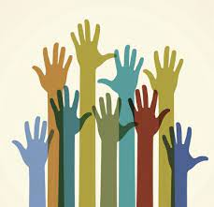  Social Justice and Equity | 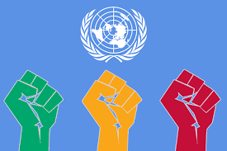  Human rights | 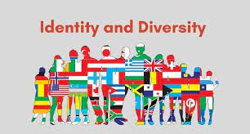  Identity and Diversity | Power and Governance | 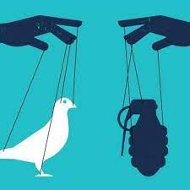  Peace and conflict | 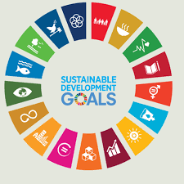Sustainable Development
Sequences of lessons are carefully crafted around a final project outcome. The learning journeys are active, engaging, and inspiring, leading to a deeper understanding of the global themes and curriculum areas. Carefully crafted sequences allow children the opportunity to develop 21st century skills such as research, collaboration, innovation, presentation, evaluation, and reflection.
When designing sequences of learning across the curriculum, we use a teaching backwards approach. At the heart of teaching backwards is a thinking process that enables our teachers to plan and teach from a clear and well-defined destination. We believe that teaching backwards is a journey that starts with the end very clearly in mind. With this knowledge, our staff design learning that focuses on small steps of progression. By slowing learning down, we ensure that our focus remains on depth. Our journeys are supported at all times by high expectations.
Metacognition plays a pivotal role with our sequences through explaining and reasoning, thinking about evidence, evaluating, and making judgements or decisions. Through deeper thinking and reflection, children are able to make links between topics so they are learning to think systematically. Teaching children how to reflect, explain, justify and question is key to lesson design. Teachers follow Rosenshine’s Principles of Instruction when teaching all subjects to ensure the children gain more knowledge and retain the knowledge, building upon it as they progress throughout the school.
Impact
Feedback is integrated into our curriculum design, and a range of feedback types are provided throughout the sequences. Provocative prompts are used to deepen the connection with the learning and encourage children to reflect at a deeper level.
Across our school and wider Trust, we use regular and robust triangulated monitoring to gauge the impact of our curriculum design. Leaders at all levels review learning, talk with our children, and provide feedback to move practice forward. We ensure that our children’s attainment and progress are in line or exceeding their potential. We measure this using national data (where appropriate), our curriculum maps, KPI documents and monitoring evidence. Our curriculum ensures that we develop well-rounded citizens with a clear understanding of values such as love, responsibility, and friendship. Our new curriculum addresses negative stereotyping through investigating similarities and differences, and promoting acceptance, diversity, citizenship, and human rights.
Our children will be motivated by a strong personal sense of morality. They will be able to make sense of an increasingly globalised, complex, and rapidly changing world. They will make decisions for the right reasons and in the best interests for our community. The children become confident in speaking about current issues through collaborative learning activities. They will be able to decide what is right and what is wrong and will be resilient to the influence of others. The children develop an awareness of how their own actions can impact others and the wider community. They will go out into the world and make a difference in their own life and to others.

